# A MINI-PROJECT REPORT ON

“ARA”

***Submitted to***

**Rashtrasant Tukadoji Maharaj Nagpur University, Nagpur *in partial fulfillment of the requirement for the degree of BACHELOR OF TECHNOLOGY***

***in***

***Computer Science & Engineering***

**Submitted By**

**Kaustubh Warade Aditya Deshmukh**

**Devansh Parapalli Yashasvi Thool**

**under the Guidance of**

***Dr. D. J. Chaudhary***



**Department of Computer Science & Engineering Government College of Engineering**

**Nagpur – 441108 (M. S.) 2023-2024**

***Certificate***

***This is to certify that the mini-project entitled***

“ARA”

***Is a bonafide work and it is submitted to the Rashtrasant Tukadoji Maharaj Nagpur University, Nagpur.***

***By***

## Kasustubh Warade Aditya Deshmukh

**Devansh Parapalli Yashasvi Thool**

***For the partial fulfillment of the requirement for the degree of Bachelor of Technology in Computer Science & Engineering, during the academic year 2023-2024.***



***Dr. D. J. Chaudhary Dr. Latest Malik***

***Project Guide Head of CSE Dept.***

**Department of Computer Science & Engineering.**

**Government College of Engineering,**

**Nagpur – 441108 (M. S.) 2023-2024**

**ACKNOWLEDGMENT**

It gives me immense pleasure in submitting the mini-project report on

**“ARA”**

to my guide **Dr. D. J. Chaudhary**, and Head of Department **Dr. Latesh Malik,** Computer Science & Engineering Department, who was a constant source of guidance and inspiration through the seminar work.

I am also very thankful to all staff members of the Computer Science & Engineering department; whose encouragement and suggestions help me to complete the Mini-Project work.

I also express my sincere gratitude to our respected Principal **Dr. Rewatkumar Pithuji Borkar** for providing us necessary facilities.

At last, I am thankful to my friend whose encouragement and constant inspiration helped me to complete this seminar work verbally and theoretically.

Kaustubh Warade  
Aditya Deshmukh   
Devansh Parapalli Yashasvi Thool  
 Third Year B.Tech,

Computer Science & Engineering, Government College of Engg., Nagpur.

**ABSTRACT**

*Nowadays academic activities/events are as much important as theory exams to gain credit. Teachers, students are encouraged to take up research and innovate. Current accreditation, ranking and grading norms emphasizes research work and publications by both students and faculty. In order to take up research work and subsequently make publications of research findings, to collaborate and network with others who are working on similar problems there is a need to participate in global, national and local workshops, seminars, symposia, conferences, etc. Students have to search for information about dates, places and themes of such academic confluences. Our project Academia Hub provides a platform where students can go and get updates about latest upcoming events held on university or college level. Academia Hub lists out all the academic activities across the country and universities in chronological order and in subject areas. It provides information about webinars, hackathons, seminars, club events, department events, fests, sports, etc. and categorizes events according to clubs, committees and other college.*

**TABLE OF CONTENTS**

|  |  |  |
| --- | --- | --- |
|  | **Title** | **Page No.** |
|  | **ABSTRACT** | iv |
| 1. | **INTRODUCTION** | 1 |
| 2. | **LITERATURE REVIEW** | 3 |
| 3. | **ANALYSIS** | 5 |
| 4. | **DESIGN** | 9 |
| 5. | **SYSTEM REQUIREMENTS** | 11 |
| 6. | **IMPLEMENTATION** | 14 |
| 7. | **SOFTWARE TESTING** | 20 |
| 8. | **RESULT** | 25 |
| 9. | **ADVANTAGES** | 26 |
| 10. | **DISADVANTAGES** | 27 |
| 11. | **APPLICATION** | 29 |
| 12. | **CONCLUSION** | 30 |
|  | **REFERENCES** | vii |

**LIST OF FIGURES**

|  |  |  |
| --- | --- | --- |
| **Figure No** | **Title** | **Page No**. |
| Figure 3.1: | College Website | 5 |
| Figure 3.2: | Conal Conference Alerts Website | 6 |
| Figure 3.3: | Data Thistle Website | 6 |
| Figure 4.1: | Data Flow Diagram | 9 |
| Figure 4.2: | Use Case Diagram | 10 |
| Figure 4.3: | Activity Diagram | 10 |
| Figure 6.1: | Home Page | 14 |
| Figure 6.2: | Publish Page | 15 |
| Figure 6.3: | Login/Registration Page | 16 |
| Figure 6.4: | Publish Event Page | 16 |
| Figure 6.5: | Events list page | 17 |
| Figure 6.6: | Event Description Page | 18 |
| Figure 6.7: | Categories Page | 18 |

**LIST OF TABLES**

|  |  |  |
| --- | --- | --- |
| **Table No** | **Title** | **Page No.** |
| Table 5.1: | Hardware Requirements | 13 |
| Table 5.2: | Hardware Requirements | 13 |
| Table 7.1: | Test Cases for integration testing | 22 |

**CHAPTER 1**

**INTRODUCTION**



Academic activities/events are as much important as theory exams to gain credit in colleges. The recruiters look out for the academic performance and the participation in different activities and events of the students. So, there is a need to participate in these events. Teachers, students are encouraged to take up research and innovate. Current accreditation, ranking and grading norms emphasizes research work and publications by both students and faculty. In order to take up research work and subsequently make publications of research findings, to collaborate and network with others who are working on similar problems there is a need to participate in global, national and local workshops, seminars, conferences, etc. A platform where students can look out for upcoming activities and events is much needed to remain updated.

# PROBLEM STATEMENT

There is no separate platform available for college to list out all the upcoming academic activities held on university or college level so that students can participate in those without missing the deadlines. Students have to search for information about dates, places and themes of such academic confluences. Lot of time and efforts are wasted in this regard and despite that they may miss out vital information and chance to make presentations. Addressing this problem will be extremely useful for obtaining the information about all academic activities across the country, universities and international arena in chronological order and in subject areas so as to enable the students, faculty, and researchers to access information and prepare well in advance and participate effectively and successfully.

We need a separate portal where information about all academic activities across the country, universities and international arena is available in chronological order and in subject areas so as to enable the students, faculty, and researchers to access information and prepare well in advance and participate effectively and successfully.

# PROPOSED SOLUTION

Solution for this problem is a separate academic portal where students can go and get updates about latest events held on university level or college level. A portal where information about all academic activities is present in chronological order so that students can prepare for these events before time and not miss the deadline.

A platform where students can access information about upcoming events such as webinars, seminars, hackathons, club events, department events, college fests, sports, and many more.

Without an event website and registration page, potential attendees won’t be able to find you, attendance at your event may be low, and you’ll have no data to inform your decision-making to keep attendees engaged. An event website keeps working after your event concludes as a great hub for nurturing leads, networking, and redirecting traffic when everything’s said and done.

Our website is mainly created to provide attendees with a list of upcoming websites with their links. Commonly, a lot of us have a hard time looking up events and finding their pages. Event listing websites make the search operation easy for people.

**CHAPTER 2**

**LITERATURE REVIEW**



There are some event listing websites available on the internet that lists event information and are used by organizer to promote their events. But these websites are for everyone and not for specific college. College students need a platform where they can find information related to their fields. Academia Hub is the platform where students can go to see event information. Event listing websites review:

1. The importance of event listings for college students: Studies have shown that college students are highly interested in attending events on and off- campus, and that event listings can play a critical role in helping them find and plan for these experiences.
2. Case studies of successful event listing websites: Looking at examples of successful event listing websites, both in and outside of the college context, can provide valuable insights into what works and what doesn't when it comes to creating a user-friendly and engaging platform.
3. The impact of event listings on student engagement and retention: Research has shown that students who are more engaged with campus life and extracurricular activities are more likely to persist and graduate, making event listings an important tool for promoting student success.
4. Challenges and opportunities for event listing websites: As with any online platform, event listing websites face a range of challenges, from managing user-generated content and ensuring data privacy to competing with social media and other online platforms for student attention. However, there are also many opportunities to innovate and improve upon existing models, such

as by integrating social networking features or using machine learning algorithms to personalize event recommendations.

**CHAPTER 3**

**ANALYSIS**



# EXISTING SYSTEM

Websites similar to our website that are available on the internet and our website has most functions in common. But there are some limitations of these websites. Some websites are mentioned below.

1. GCOEN (<https://www.gcoen.ac.in/>)

This is a college website of GCOEN which contains all the information of college.

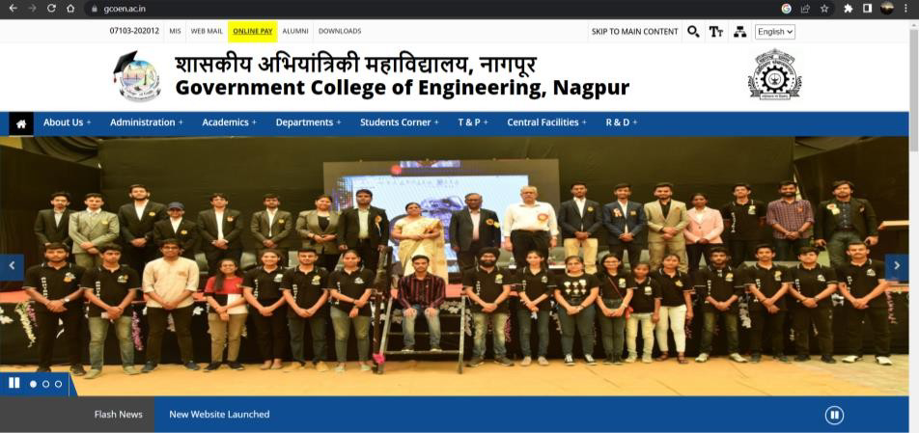

**Figure 3.1: College Website**

1. Conal Conference Alerts (<https://conferencealerts.com/>)

Conference Alerts provides all national and international upcoming conferences 2023 all over the world.

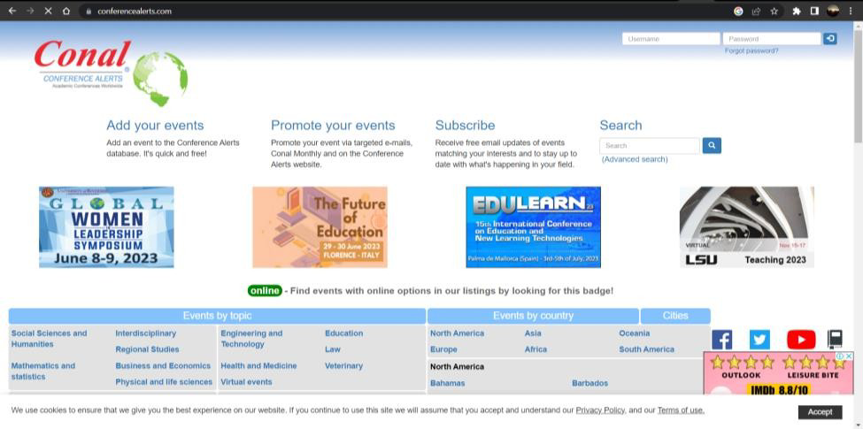

**Figure 3.2: Conal Conference Alerts Website**

1. Data Thistle (<https://www.datathistle.com/>)

Data Thistle is a listings technology business that provides the UK's largest and best set of live events data.

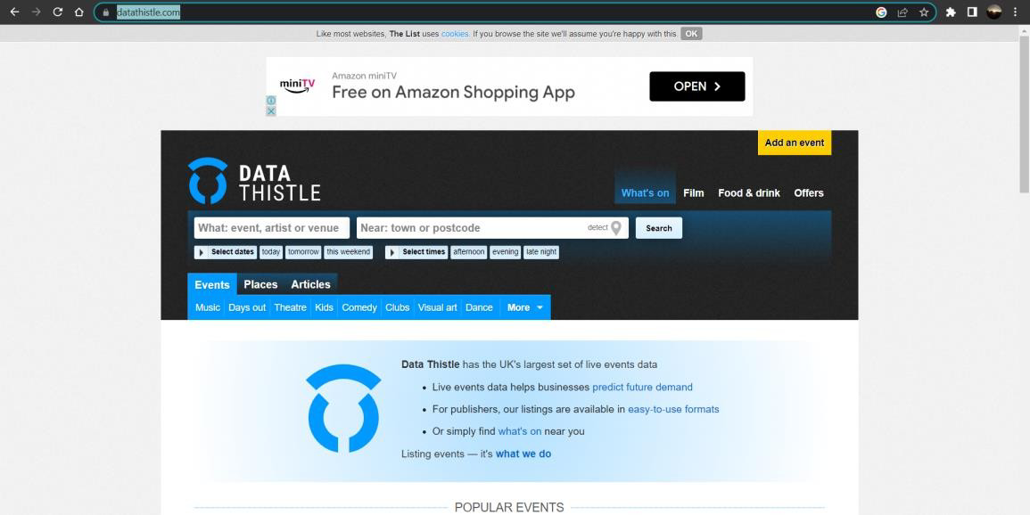

**Figure 3.3: Data Thistle Website**

# LIMITATIONS OF EXISTING SYSTEM

## GCOEN

In GCOEN website there is no separate option to view upcoming activities that will keep students updated in the college website. There is an option “Department Activities”, but no content is available in that. Club activities are not updated since a long time. It does not contain any option that categorizes activities into different domains and lists them in chronological order.

## Conal Conference Alerts

Conal Conference Alerts enables organizer to add their events to promote them but this website is not helpful for college students to view activities happening in their college. Drawbacks of Conal Conference Alerts website:

* 1. Limited Scope: Conference alerts are typically focused on a particular field or industry. If you are interested in multiple field, you may need to subscribe to alerts from multiple sources, which can be time consuming and overwhelming.
  2. Cost: Some conferences alert services may charge a fee for providing information or for access to their full database, which can be additional cost consider.
  3. Lack of customization: Conal Conference Alerts website may not offer the level of customization that some users require. For example, you may not be able to filter alerts by location or topic, which can result in overwhelming number of alerts that do not match your interests.

## Data Thistle

Data thistle accepts events and conferences happening in and around UK but it does not accept virtual events which are really popular these days and attracts a large number of audiences.

**CHAPTER 4**

**DESIGN**



# DATA FLOW DIAGRAM

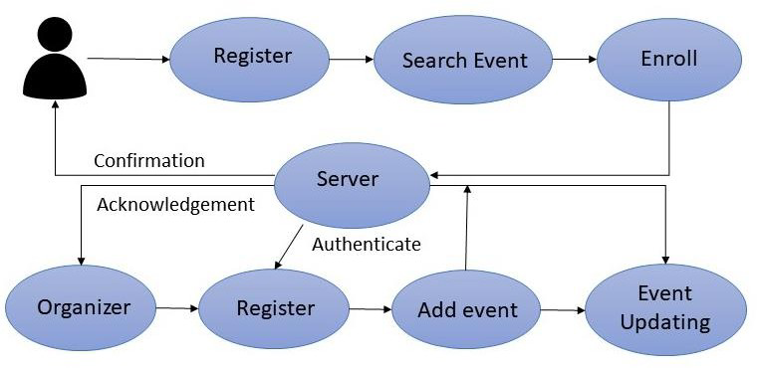

**Figure 4.1: Data Flow Diagram**

# USER CASE DIAGRAM

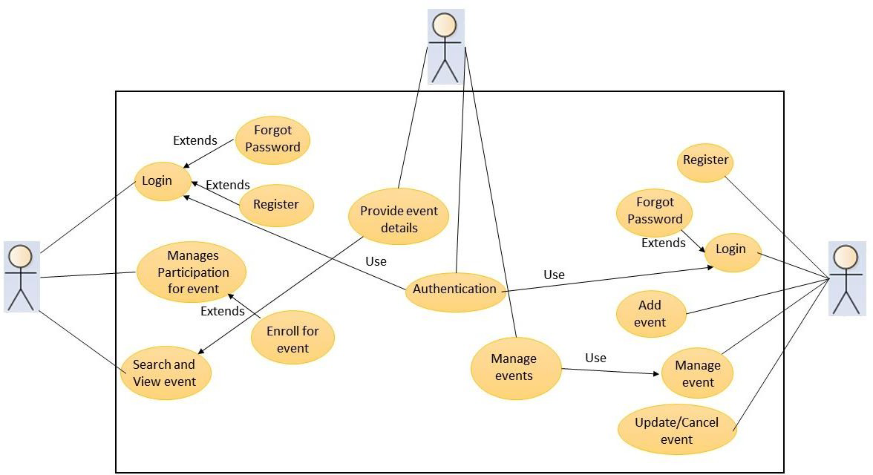

**Figure 4.2: User Case Diagram**

# ACTIVITY DIAGRAM



Login

Authentication

Check

Invalid

Valid

PublishEvent

EditProfile

ViewEvents

ViewEvents

ChangePassword

FilterEvents

DeleteEvent

Enrollinanevent



Logout

**Figure 4.3: Activity Diagram**

**CHAPTER 5**

**SYSTEM REQUIREMENTS**



# SOFTWARE REQUIREMENTS

## UI/UX & Prototyping - Figma

Figma is a powerful web-based design tool that helps you create anything, websites, applications, logos, and much more. You'll take your first steps into User Interface Design and User Experience Design by learning how to use Figma.

## Frontend: HTML + CSS

[HTML or HyperText Markup Language](https://www.simplilearn.com/tutorials/html-tutorial/what-is-html) is used for creating web applications and websites. It is used for describing the structure of Web pages.

[CSS](https://www.w3.org/Style/CSS/) is the language for describing the presentation of Web pages, including colors, layout, and fonts. It allows one to adapt the presentation to different types of devices, such as large screens, small screens, or printers.

## Backend – PHP + JavaScript

PHP is a server-side scripting language and a powerful tool for making dynamic and interactive Web Pages.

JavaScript is a client-side scripting language. It is the programming language of the Web. The two languages are adaptable and can work well together and separately.

1. **Database – MySQL**

MySQL is a widely used relational database management system (RDBMS) based on the Structured Query Language, which is the popular language for accessing and managing the records in the database. MySQL is open-source

and free software under the GNU license. It is supported by Oracle Company.

## Browser – Chrome/Edge

The main function of a browser is to present the web resource you choose, by requesting it from the server and displaying it in the browser window. A web browser is a software application specifically for the purpose of reading HTML instructions and displaying the resulting Web page. It is a fully functional software that can interpret and display HTML Web pages. Chrome is the most popular web browser used.

## IDE/Workbench – Visual Studio Code

Visual Studio Code is a streamlined code editor with support for development operations like debugging, task running, and version control. It aims to provide just the tools a developer needs for a quick code-build-debug cycle and leaves more complex workflows to fuller featured IDEs, such as Visual Studio IDE.

# HARDWARE REQUIREMENTS

## For Project Development

**Table 5.1: Hardware Requirements**

|  |  |  |  |
| --- | --- | --- | --- |
| Sr no. | Hardware | Specifications | Quantity |
| 1. | Computer system | Intel(R) Core (TM) i5, 1TB HDD, minimum 8GB RAM, Windows 10. | 1 |

## Client-Side Requirements

**Table 5.2: Hardware Requirements**

|  |  |  |  |
| --- | --- | --- | --- |
| Sr no. | Hardware | Specifications | Quantity |
| 1. | Computer system | Intel(R) Core (TM) i5, 1TB HDD, minimum 4GB RAM, Windows 10. | 1 |

**CHAPTER 6**

**IMPLEMENTATION**



# HOME PAGE

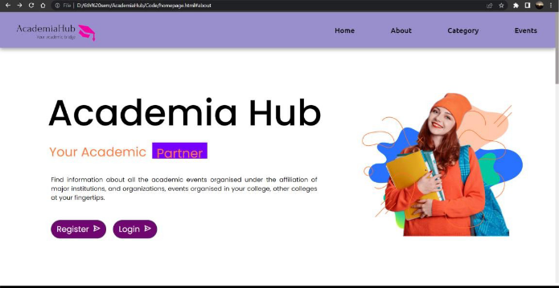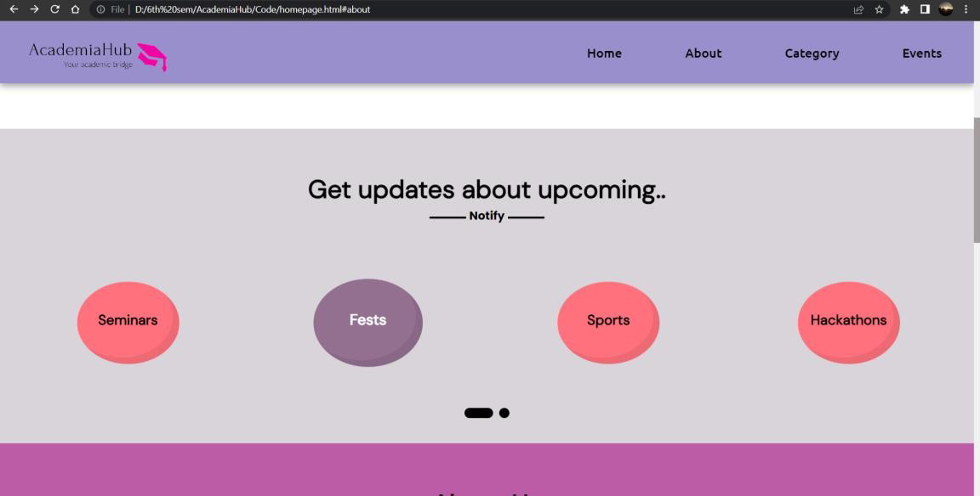

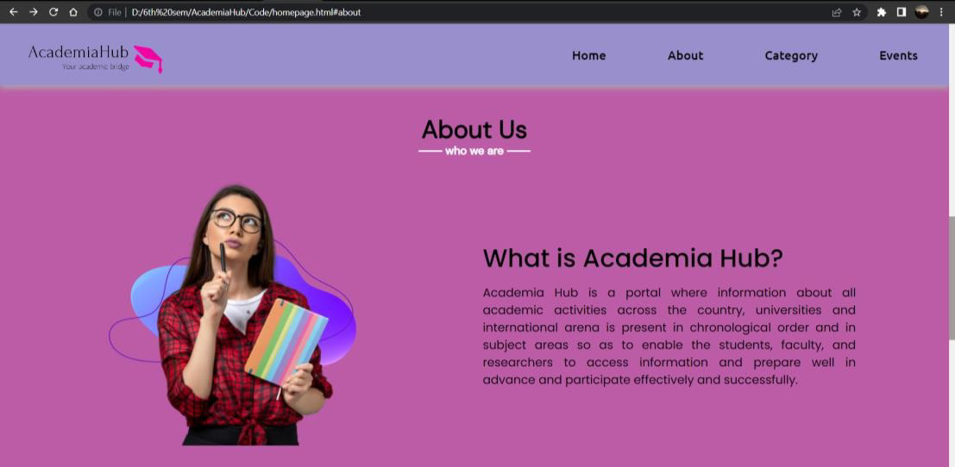

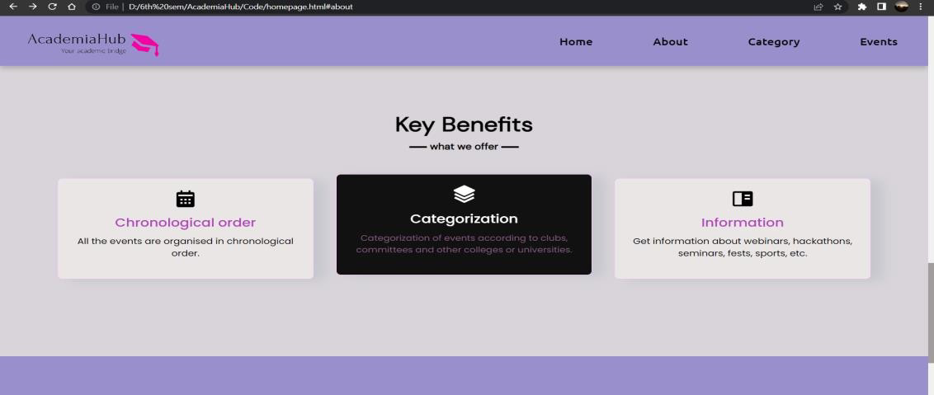

* 1. **PUBLISH PAGE**

**Figure 6.1: Home page**

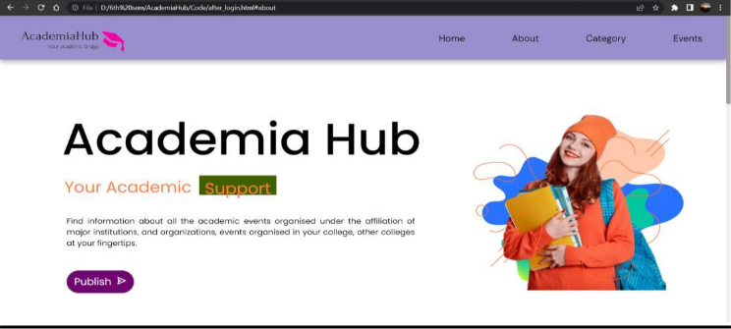

**Figure 6.2: Publish page**

# LOGIN / REGISTER PAGE

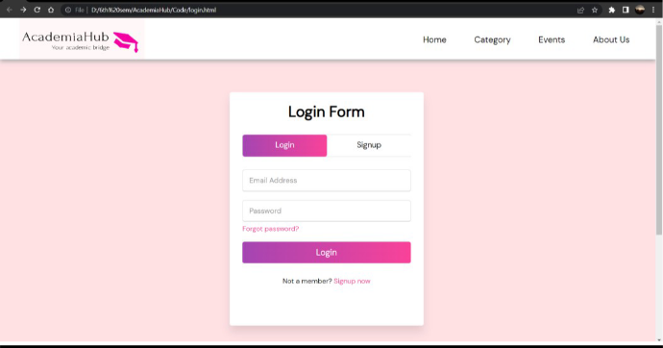

**Figure 6.3: Login/Registration page**

# PUBLISH EVENT PAGE

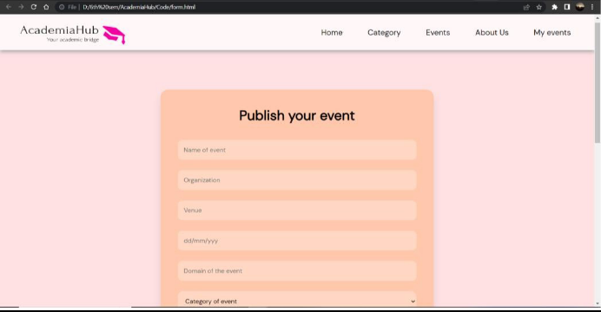



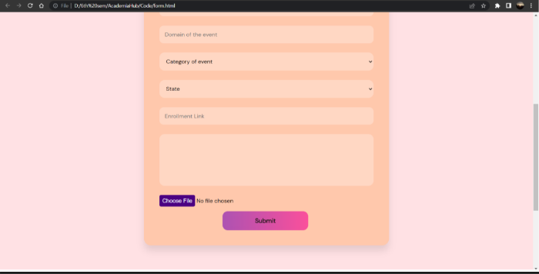

* 1. **EVENTS LIST**

**Figure 6.4: Publish Event page**

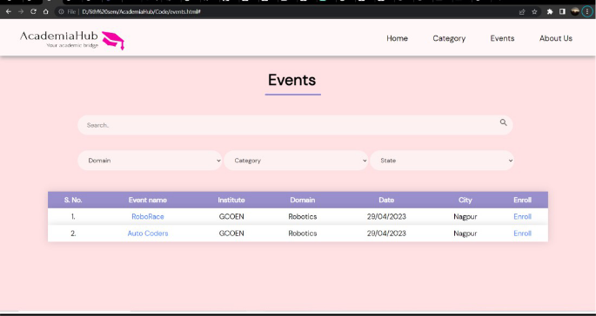

**Figure 6.5: Events list page**

* 1. **EVENT DESCRIPTION**

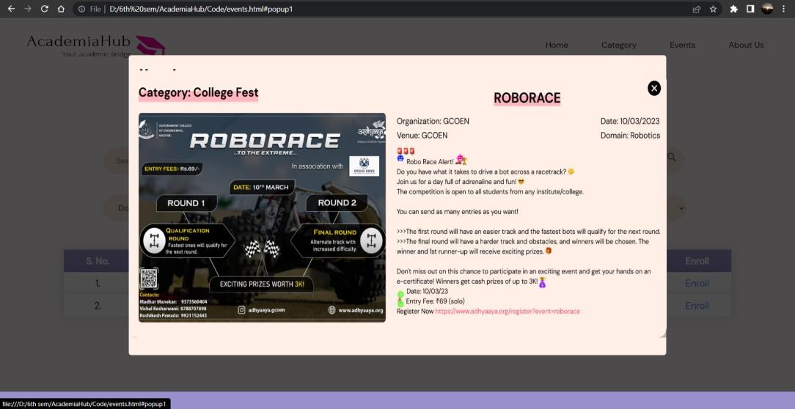

**Figure 6.6: Event description page**

# CATEGORIES PAGE

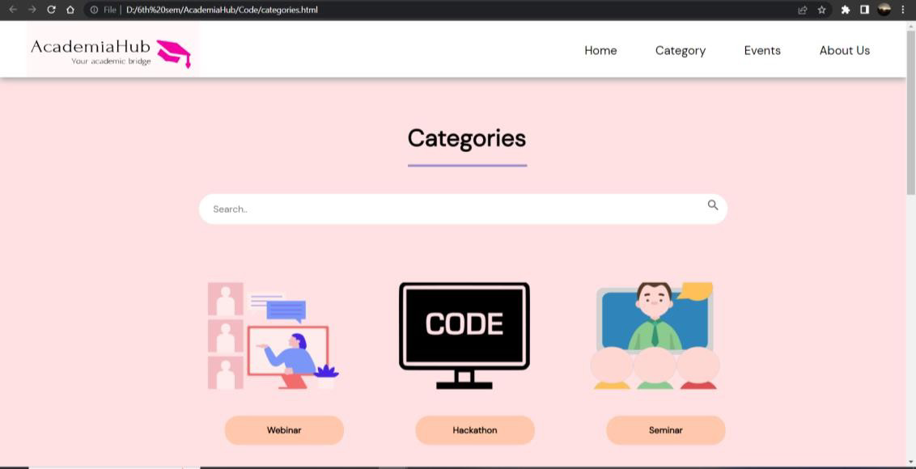



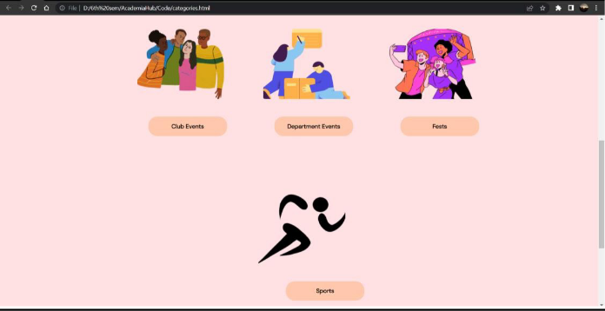

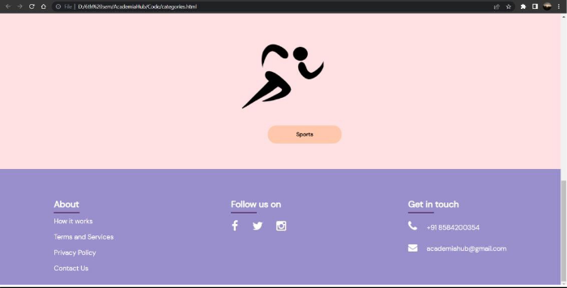

**Figure 6.7: Categories page**

**CHAPTER 7**

**SOFTWARE TESTING**



Testing is a set of activity that can be planned and conducted systematically. Testing begins at the module level and work towards the integration of entire computers-based system. Nothing is complete without testing as it is vital success of the system.

There are several rules that can serve as testing objectives, they are:

* + 1. Testing is a process of executing a program with the intent of finding an error.
    2. A good test case is one that has high probability of finding an undiscovered error.
    3. A successful test is one that uncovers an undiscovered error.

# TESTING METHOD

As part of our software testing approach, the strategy that has been incorporated is **white box testing** to thoroughly examine the internal structure, logic, and code of our project. White box testing allows us to gain insights into the internal workings of the software and identify and address any potential defects or issues that may arise from the code.

The use of white box testing in our testing process involves the following steps:

* + 1. **Code Review:** Review the source code of the website to ensure it follows coding standards, is well-organized, and free from syntax errors, logic errors, and security vulnerabilities**.**
    2. **Unit Testing:** Conduct unit testing on individual code modules or components to verify if they are functioning as intended. This may include testing of functions, classes, and methods used in the website**.**
    3. **Function Testing:** Test the functions or features of the website to ensure they are working correctly. This may include testing of AR Virtual Try- on, Online Measurement, Customization Options, Size Recommendations, Order Placement, User Account Registration, and other relevant features**.**
    4. **Boundary Testing:** Test the website with boundary values to check if it handles extreme or edge cases properly. For example, test with minimum and maximum input values for body measurements, garment sizes, customization options, etc**.**
    5. **Error Handling Testing:** Test the website's error handling mechanisms to ensure they are handling errors and exceptions gracefully, providing meaningful error messages to users, and preventing potential security risks**.**
    6. **Compatibility Testing:** Test the website on different browsers, devices, and operating systems to ensure it works correctly across different platforms and configurations**.**
    7. **Security Testing:** Conduct security testing to identify and fix any vulnerabilities, such as SQL injection, cross-site scripting (XSS), cross- site request forgery (CSRF), etc., to ensure the website is secure and protects user data**.**
    8. **Performance Testing:** Test the website's performance under different load conditions to ensure it can handle expected traffic and user interactions without performance degradation**.**
    9. **Integration Testing:** Test the integration of different components, modules, or third-party APIs used in the website to ensure they are properly integrated and functioning as expected.
    10. **Regression Testing:** Conduct regression testing to ensure that changes or updates to the website do not introduce new defects or impact the functionality of existing features.
    11. **Test Reporting:** Document and report any defects, issues, or observations found during testing, and track their resolution to ensure that all identified issues are fixed and verified

# TEST CASES

**Table 7.1: Test Cases for Integration Testing**

|  |  |  |  |  |  |
| --- | --- | --- | --- | --- | --- |
| **Test Case ID** | **Test Case Description** | **Test Steps** | **Expected Result** | **Actual Result** | **Status** |
| TC001 | Login – Valid Credentials | 1. Enter valid username and password | User is logged in successfully. | User is logged in successfully. | Pass |
| TC002 | Login - Invalid Credential | 1. Enter invalid username and password. | Error message should be displayed. | Error message is displayed. | Pass |
| TC003 | Testing the filtering options. | Select Domain as Robotics. | All the events under Robotics domain should be displayed. | Events under Robotics domain are displayed. | Pass |

|  |  |  |  |  |  |
| --- | --- | --- | --- | --- | --- |
| TC004 | Test the publish event functionality. | Publish an event by filling the form. | Event should be added to the list. “Event published” message should be displayed. | Event added to the events list. “Event Published” message is displayed. | Pass |
| TC005 | Test the event deletion functionality. | Delete an existing event. | Event should not be present in the event list. “Event deleted” message shoul be displayed. | Event is not present in the list. “Event Deleted” message is displayed. | Pass |
| TC006 | Home Page - Navigation | Click on “About Us” link. | About Us page should be loaded. | About Us page loaded successfully. | Pass |
| TC007 | Only Admin should be able to publish event. | Publish event as a User. | “You cannot publish an event. Only Admin can publish” message | “You cannot publish an event. Only Admin can publish” message is | Pass |

|  |  |  |  |  |  |
| --- | --- | --- | --- | --- | --- |
|  |  |  | should be displayed. | displayed. |  |
| TC008 | Event details popup. | Click on the event name. | A overlay should popup containing event details upon clicking on the event name. | A overlay pops up containing event details upon clicking on the event name. | Pass |
| TC009 | Enroll button working | Click on the Enroll button of an event. | It should redirect us to an enrollment link to another webpage upon clicking. | We are redirected to another webpage of enrollment upon clicking on the button. | Pass |

.

**CHAPTER 8**

**RESULT(S)**



Academia Hub gives students a platform wherein they can search for events information saving their time and reducing efforts.

1. **Increased Knowledge Sharing:** Can facilitate knowledge sharing among academics by providing a platform for publishing and accessing academic events.
2. **Improved Collaboration:** A collaborative platform can enable academics, and students to collaborate on exchange ideas and information, and form partnerships across academic disciplines and institutions.
3. **Enhanced Visibility:** Website can increase the visibility of academic programs, and events, leading to more significant participation and engagement from the academic community and the public.
4. **Enhanced Networking:** The website can be used as a networking tool for academics to connect with peers and potential collaborators.

**CHAPTER 9**

**ADVANTAGES**



Advantages of Academia Hub:

1. Our project serves as a central hub for attendees to find information, register and learn more about a company or organization.
2. Increase attendance level: Most of the events has low attendance due to lack of information. This website will help in increasing attendance of an event.
3. It helps to increase registration numbers while providing attendees with important event information.
4. Academia Hub helps in organizing pertinent information all in one place so that attendees do not have to search for information about events from different sources.
5. Organizers have a big advantage to promote their event among the students.
6. The website also helps in boosting engagement and generating leads.
7. An event website keeps working after an event concludes as a great hub for nurturing leads, networking, and redirecting traffic when everything’s said and done.
8. Chronologically ordered events makes it easier to enroll for the events within time without missing the deadline.
9. Filter events according to domain, category and state. It makes it easier for attendees to find events and saves a lot of their time.

**CHAPTER 10**

**DISADVANTAGES**



There are some downsides of the website. Adding listings to these sites is time consuming, taking up hours or even days depending on the number of events and how many sites are used. Additionally, sometimes editorial restrictions on the individual listing sites make it difficult to accept all of your promotional material, such as event images, full description and Pdf attachments.

1. **Limited audience**: Depending on the scope and focus of the website, it may only attract a small audience, such as students and faculty from a single college or university. This can limit the potential impact of the website and reduce its usefulness for those outside of the college community.
2. **Competition from other event listings**: There are many other websites and platforms that already exist for promoting events, such as social media, community calendars, and event-specific websites. Competing with these established sources can be difficult and may limit the website's reach
3. **Lack of resources**: Creating and maintaining a website can be time- consuming and require technical expertise. Without sufficient resources, such as a dedicated team of developers and content creators, the website may not be able to compete with more established event listing platforms.
4. **Limited event coverage**: Depending on the size of the college or university, it may be difficult to cover all of the events happening on campus. This can result in an incomplete or inaccurate representation of the events available, which may lead to frustration for users.
5. **Difficulty in keeping information up-to-date**: Events can be added or changed at any time, and keeping up with these updates can be challenging.

If the website is not regularly maintained and updated, users may lose trust in the accuracy of the information and stop using the website altogether.

**CHAPTER 11**

**APPLICATIONS**



Academia has the potential to make students lives easier and save their time by ensuring that all the information about the events is available at one place.

Here are some potential applications for the project:

* 1. Add, remove, and organize your event listings.
  2. Assign event locations to each of your events, and group them by those locations.
  3. Event organizers can log in and access full event management features, such as viewing, editing and deleting event.
  4. Displays event information uploaded by the organizer along with the photo.
  5. Filter events according to domain, category and state. It makes it easier for attendees to find events and saves a lot of their time.
  6. Browse the event schedule and agenda. This website provides details, often the source of truth for all planned activities, which gives potential attendees insight into what they can expect if they choose to attend.
  7. Organizers of event can promote their event on this platform to reach to a wider interested audience.
  8. Students or attendees gets a platform where they can search for event information at one place without going to different sources.

**CHAPTER 12**

**CONCLUSION**



In conclusion, Academia Hub serves as a platform for disseminating information, promoting collaboration, and facilitating the exchange of ideas among academics, students, and the general public. Overall, Academia Hub has the potential to bring together individuals from different academic disciplines and backgrounds to promote knowledge-sharing and innovation. Academia Hub serve as a hub for connecting individuals, sharing ideas, and advancing research and knowledge in various fields.

Academia Hub is a platform where students can look out for upcoming activities and events is much needed to remain updated. Students need to utilize their time efficiently and Academia Hub helps them to search for information about events at one place.

**REFERENCES**

1. Ether, N. (2023). The importance of an event website (with examples).

Webex Events (Formerly Socio). *https://socio.events/blog/event-website*

1. Team, A. E. C. (n.d.). Event Marketing: Strategy Guide + Tips. *https://business.adobe.com/blog/basics/event- marketing#:~:text=Event%20marketing%20describes%20the%20process*

*,or%20host%20an%20event%20yourself.*

1. Caldecott, S. (2021, December 13). The Importance of Event Marketing - First Event - Medium. Medium. *https://medium.com/first-event/the- importance-of-event-marketing-28a8ee2331ed*
2. Adhikari, B. D. (2022). Best Event Listing Portals In India. StartupTalky.

*https://startuptalky.com/event-listing-portals-india/*

1. Chudasama, P. (2023, March 30). Largest Collection of Event Listing Websites Categorized for 2023 - AllEvents. AllEvents. *https://allevents.in/blog/top-event-listing- websites/#:~:text=These%20sites%20allow%20users%20to,Alltech%20c onferences*
2. Muhammad, F. (2023). What is Event Marketing? Instapage.

*https://instapage.com/what-is-event-marketing/*

1. What is Event Marketing: Strategies, Ideas, Examples | SendPulse. (n.d.). SendPulse. *https://sendpulse.com/support/glossary/event-marketing*